

**DEPT. of Computer Science Engineering**

**SRM IST, Kattankulathur – 603 203**

**Sub Code & Name: 18CSS201J - ANALOG AND DIGITAL ELECTRONICS**

|  |  |
| --- | --- |
| **Experiment No** | 06 |
| **Title of Experiment** | Design and implementation of Binary to gray code converters and vice versa using logic gates |
| **Name of the candidate** |  |
| **Register Number** |  |
| **Date of Experiment** |  |

**Mark Split Up**

|  |  |  |  |
| --- | --- | --- | --- |
| **S.No** | **Description** | **Maximum Mark** | **Mark Obtained** |
| 1 | Oral Viva | 5 |  |
| 2 | Circuit Connection and Execution | 10 |  |
| 3 | Verification of truth table | 5 |  |
| **Total** | | **20** |  |

**Staff Signature with date**

# Design and implementation of Binary to gray code converters using logic gates

## AIM

* + 1. To design and implementation of Binary to gray code converters using Multisim-online software.
    2. Hardware Implementation of the same with virtual Lab - IIT Bombay

**SOFTWARE REQUIRED**

[**https://www.multisim.com/**](https://www.multisim.com/)

## APPARATUS REQUIRED

|  |  |  |  |  |
| --- | --- | --- | --- | --- |
| **S.No** | **Apparatus** | **Type** | **Range** | **Quantity** |
| 1 | IC | IC 7486 |  | 1 |
| 2 | LED |  |  | 4 |
| 3 | Switch |  |  | 4 |
| 4 | DC Power Source |  |  | 1 |
| 5 | Multisim online  virtual lab IIT Bombay |  |  |  |
| 6 | Wires |  |  | As Required |

**THEORY**

The logical circuit which converts binary code to equivalent gray code is known as binary to gray code converter. The gray code is a non-weighted code. The successive gray code differs in one-bit position only that means it is a unit distance code. It is also referred as cyclic code. It is not suitable for arithmetic operations. It is the most popular of the unit distance codes. It is also a reflective code. An n-bit Gray code can be obtained by reflecting an n-1-bit code about an axis after 2n-1 rows, and putting the MSB of 0 above the axis and the MSB of 1 below the axis. This method uses an Ex-OR gate to perform among the binary bits. In this conversion method, take down the MSB bit of the present binary number, as the primary bit or MSB bit of the gray code number is similar to the binary number.

To get the straight gray coded bits for generating the corresponding gray coded digit for the given binary digits, add the primary digit or the MSB digit of binary number toward the second digit & note down the product next to the primary bit of gray code, and add the next binary bit to third bit then note down the product next to the 2nd bit of gray code. Similarly, follow this procedure until the final binary bit as well as note down the outcomes depending on [EX-OR logic operation](https://www.elprocus.com/basic-logic-gates-with-truth-tables/) to generate the corresponding gray coded binary digit.

## PROCEDURE

1. Open Multisim. Sign in.
2. Open a new circuit file
3. Select the components
   * Go to digital, choose digital constants
   * Go to digital, choose XOR 2 input gate
   * Go to indicator, choose LED bulbs
   * Go to schematic connectors, choose ground
4. Duplicate the components and connect them as per circuit diagram.
5. From analysis and annotation choose digital probe and place them where the output bits are to be seen
6. Run the simulation and verify the output
7. To change the input values, vary the values of high and low on the digital constants and verify the complete truth table illustrated below.

## CIRCUIT DIAGRAM:

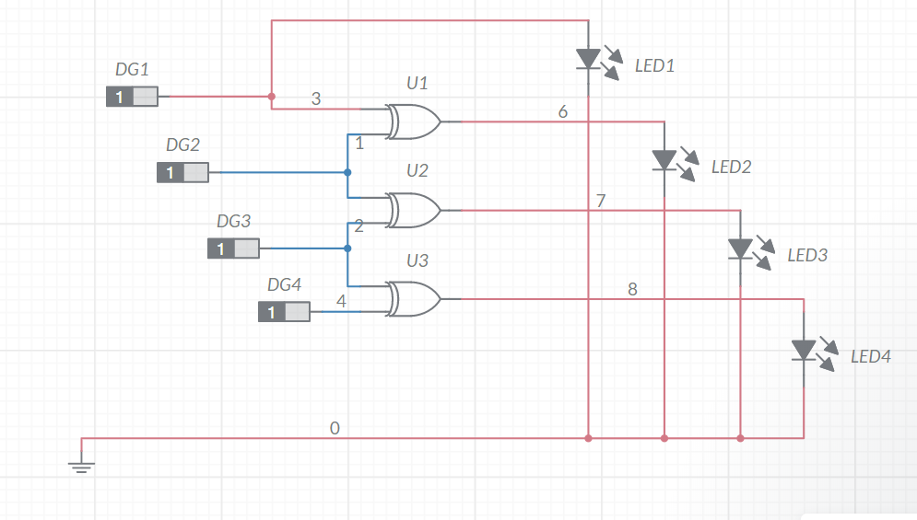

## TRUTH TABLE

|  |  |  |  |  |  |  |  |
| --- | --- | --- | --- | --- | --- | --- | --- |
| **BINARY** | | | | **GRAY CODE** | | | |
| **B3** | **B2** | **B1** | **B0** | **G3** | **G2** | **G1** | **G0** |
| 0 | 0 | 0 | 0 | 0 | 0 | 0 | 0 |
| 0 | 0 | 0 | 1 | 0 | 0 | 0 | 1 |
| 0 | 0 | 1 | 0 | 0 | 0 | 1 | 1 |
| 0 | 0 | 1 | 1 | 0 | 0 | 1 | 0 |
| 0 | 1 | 0 | 0 | 0 | 1 | 1 | 0 |
| 0 | 1 | 0 | 1 | 0 | 1 | 1 | 1 |
| 0 | 1 | 1 | 0 | 0 | 1 | 0 | 1 |
| 0 | 1 | 1 | 1 | 0 | 1 | 0 | 0 |
| 1 | 0 | 0 | 0 | 1 | 1 | 0 | 0 |
| 1 | 0 | 0 | 1 | 1 | 1 | 0 | 1 |
| 1 | 0 | 1 | 0 | 1 | 1 | 1 | 1 |
| 1 | 0 | 1 | 1 | 1 | 1 | 1 | 0 |
| 1 | 1 | 0 | 0 | 1 | 0 | 1 | 0 |
| 1 | 1 | 0 | 1 | 1 | 0 | 1 | 1 |
| 1 | 1 | 1 | 0 | 1 | 0 | 0 | 1 |
| 1 | 1 | 1 | 1 | 1 | 0 | 0 | 0 |

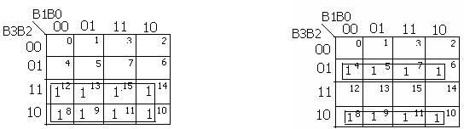G3 = ∑(8,9,10,11,12,13,14,15) G2 = ∑(4,5,6,7,8,9,10,11)



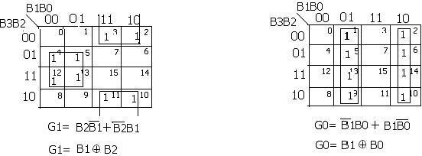G1= ∑(2,3,4,5,10.,11,12,13) G0 = ∑(1,2,3,5,6,9,10,13,14)

**Binary to Gray code converter Using XOR Gates Only**

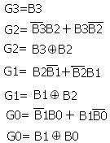

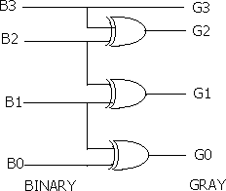

# 6.b. Design and implementation of Gray to Binary code converters using logic gates

## AIM

To design and implementation of Gray to Binary code converters using Multisim.

**SOFTWARE REQUIRED**

[**https://www.multisim.com/**](https://www.multisim.com/)

## PROCEDURE

1. Open Multisim. Sign in.
2. Open a new circuit file
3. Select the components
   * Go to digital, choose digital constants
   * Go to digital, choose XOR 2 input gate
   * Go to indicator, choose LED bulbs
   * Go to schematic connectors, choose ground
4. Duplicate the components and connect them as per circuit diagram.
5. From analysis and annotation choose digital probe and place them where the output bits are to be seen
6. Run the simulation and verify the output
7. To change the input values, vary the values of high and low on the digital constants and verify the complete truth table illustrated below.

## CIRCUIT DIAGRAM

## 

## ALTERNATE WAY

## PROCEDURE:

1. Open Multisim.
2. Select file navigation menu **→** New file
3. Select the components
   1. Go to source choose DC source and give its value as 5V
   2. Go to digital choose XOR 2 input gate
   3. Go to passive choose resistor and give its value as 100Ω.
   4. Go to schematic connectors and choose ground
4. Duplicate the components and connect them as per circuit diagram.
5. From analysis and annotation choose digital probe and place them where the output

bits are to be seen.

1. Run the simulation and verify the output
2. To change the input values connect it to the dc source or connect it to ground and verify the

complete truth table given below.

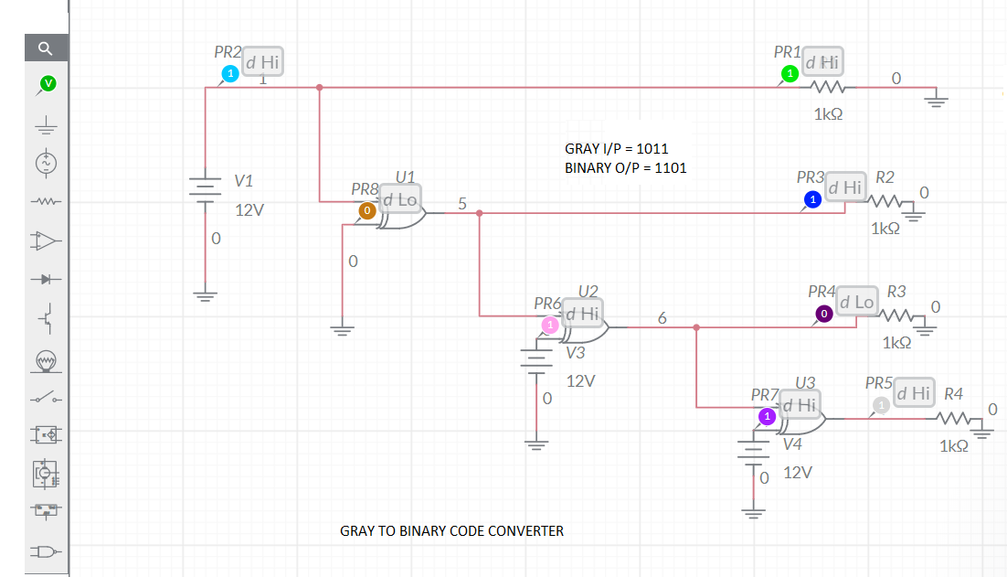

**TRUTH TABLE**

|  |  |  |  |  |  |  |  |
| --- | --- | --- | --- | --- | --- | --- | --- |
| **GRAY CODE** | | | | **BINARY CODE** | | | |
| **G3** | **G2** | **G1** | **G0** | **B3** | **B2** | **B1** | **B0** |
| 0 | 0 | 0 | 0 | 0 | 0 | 0 | 0 |
| 0 | 0 | 0 | 1 | 0 | 0 | 0 | 1 |
| 0 | 0 | 1 | 0 | 0 | 0 | 1 | 1 |
| 0 | 0 | 1 | 1 | 0 | 0 | 1 | 0 |
| 0 | 1 | 0 | 0 | 0 | 1 | 1 | 1 |
| 0 | 1 | 0 | 1 | 0 | 1 | 1 | 0 |
| 0 | 1 | 1 | 0 | 0 | 1 | 0 | 0 |
| 0 | 1 | 1 | 1 | 0 | 1 | 0 | 1 |
| 1 | 0 | 0 | 0 | 1 | 1 | 1 | 1 |
| 1 | 0 | 0 | 1 | 1 | 1 | 1 | 0 |
| 1 | 0 | 1 | 0 | 1 | 1 | 0 | 0 |
| 1 | 0 | 1 | 1 | 1 | 1 | 0 | 1 |
| 1 | 1 | 0 | 0 | 1 | 0 | 0 | 0 |
| 1 | 1 | 0 | 1 | 1 | 0 | 0 | 1 |
| 1 | 1 | 1 | 0 | 1 | 0 | 1 | 1 |
| 1 | 1 | 1 | 1 | 1 | 0 | 1 | 0 |

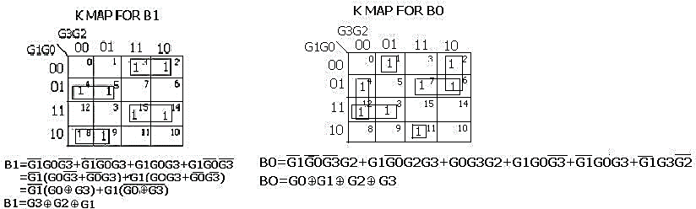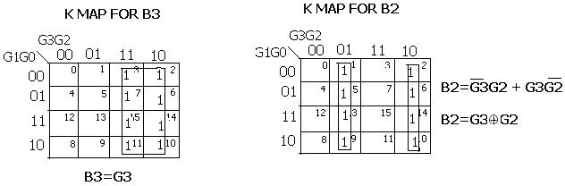

**Gray to Binary code converter Using XOR Gates Only**

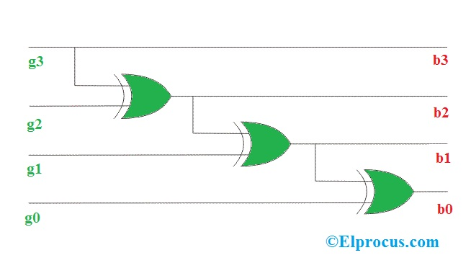

* 1. **Hardware Implementation of Code Converters Using NI Analog Discovery 2**

**Theory:**

**Introduction to NI Analog Discovery 2(AD 2):**



The Analog Discovery 2 transforms any PC into an electrical engineering workstation. This USB-powered device enables students to build and test analog and digital circuits in any environment with the functionality of traditional benchtop instruments. In addition to the 100 MS/s two-channel oscilloscope, the Analog Discovery 2 provides a two-channel waveform generator, 16-channel logic analyzer, 16-channel digital pattern generator, spectrum analyzer, network analyzer, voltmeter, and ±5 VDC adjustable power supplies.

**Introduction to Virtual Lab – IIT Bombay**

The objective of VLabsDev is to involve the community to re-think on the best practices regarding pedagogy, storyboards, lab manuals, documentation and the technologies for building a high-quality simulator.

The main activities of the VLabsDev portal currently are content creation through community, hosting the community created content, the source codes, hackathons for code and content development, events for instructors for pedagogy and storyboard design.

The academic community of students and instructors from Engineering, Science and Polytechnic institutes are the potential stakeholders as well as the beneficiaries. The objective is to provide quality Virtual Lab experiences for education.

The data collected through major universities in India indicates that, there are over 500 Labs which need to be created; (only ~120 labs of the MHRD Virtual Labs project are available for use). Therefore, there exists a huge gap in the syllabus which has to be filled by the community itself.

**AIM:**

Hardware Implementation of the code converter using NI Analog Discovery 2.

**APPARATUS REQUIRED**

|  |  |  |  |  |
| --- | --- | --- | --- | --- |
| **S.No** | **Apparatus** | **Types** | **Range** | **Quantity** |
| 1 | IC | IC 7486 |  |  |
| 2 | NI Analog Discovery 2 |  |  |  |
| 3 | Wires |  |  | As Required |
| 4 | Bread board |  |  | 1 |

**PROCEDURE:**

1. Build the Binary to Gray and Vice Versa Circuit in the breadboard.

2. Use the below pin diagram for circuit connection in breadboard.





3. Use the above pin connection from AD2.

4. Red wire belongs to power. Take a wire connect to red wire and wire it to pin 14.

5. Black wire belongs to ground. Take a wire connect to Black wire and wire it to pin 7.

6. Use Pin 0- Pin 3 of AD2 as Input.

7. Connect Pin 0- Pin 3 of AD2 to B0, B1, B2, B3.

8. Use Pin 4- Pin 7 of AD2 as Output.

9. Connect Pin 4- Pin 7 of AD2 to G0, G1, G2, G3.

10. Search the application in PC for Waveform 2015.



11. In the above window click the Supplies Instrument.



12. Use only positive supply. Change the voltage as 5.

13. Click Master Enable button to enable the Instrument.

14. In the Welcome tab, select Static IO Instrument to open.



15 Configure Digital I/O signal into a switch by selecting 0, Switch, Push/Pull (1/0) as seen in Figure below for DIO 0-DIO3



16. Run both Static IO and Power Supplies Instrument.

17. Verify the truth table by changing the switch position.

**Connection Diagram**

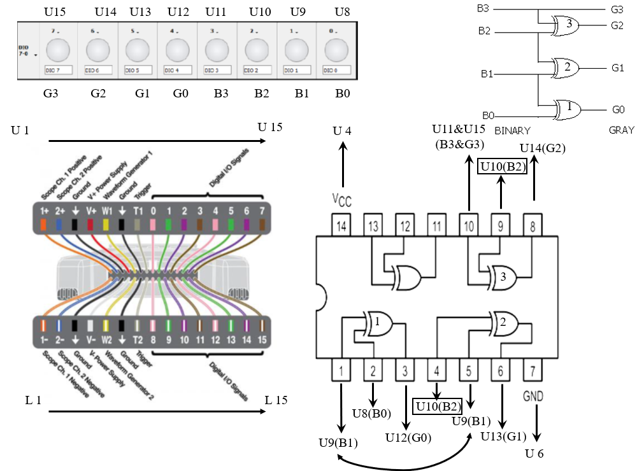

**RESULT**

Thus, design and implementation of Binary to gray code converters and Vice Versa using logic gates using Multisim and NI Analog Discovery 2.